# What is Docker? And Why?

Docker is a container technology: A tool for creating and managing containers.

## What is a container?

A container in a software terminology is a standardized unit of software. A package of code and dependencies to run that code (e.g. NodeJS code + the NodeJS runtime).

Advantages of packaging the application in a container is that it always yields the exact same application and execution behaviour! No matter where or by whom it might be executed.

Now good thing is modern operating systems have in-built support for containers and Docker simplifies the creation and management of such comtainers.

## Why containers?

In order to understand this question, we need to ask ourself a question:

Why would we want independent, standardized, “application packages”?

To answer this question, let’s consider a sample example that you have a NodeJS application which your code contains a feature await which is well supported on the versions 14.13.0 or more than.

Suppose if your production servers contains the version of 12.18.4 and if you deploy the same code on production it will throw an error. To fix this problem we can use the lock and deploy the specific version of code inside a container and deploy it on production.

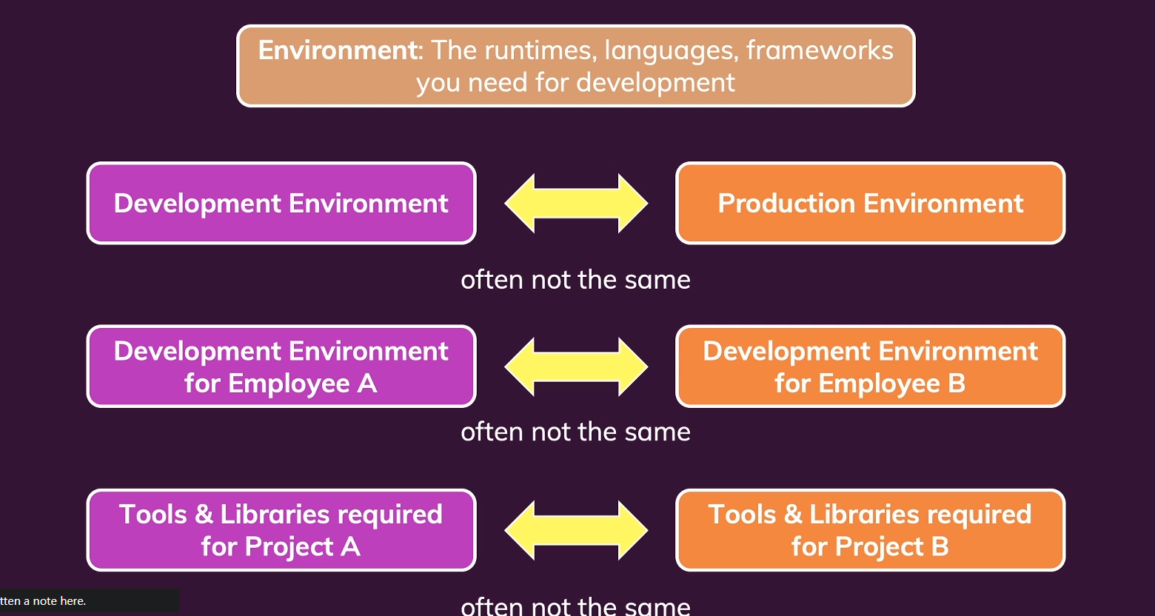

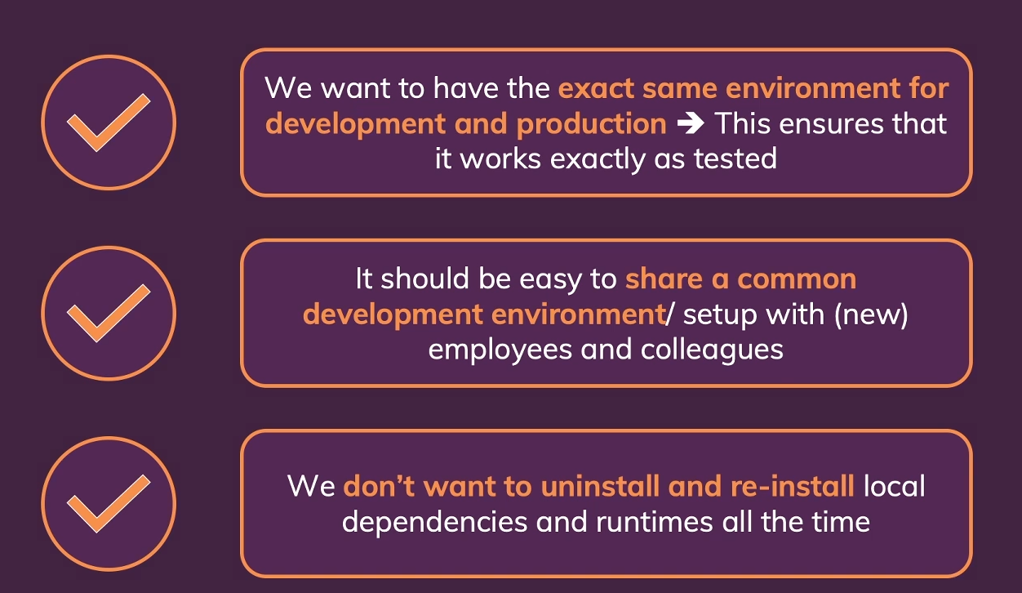

Docker overcomes this problems mentioned on above screenshot, if you require multiple versions on different environments or different teams, you many launch the respected versions of Docker containers into the respected environments.

# Virtual machines Vs Dockers

Virtual machines works like similar to the Docker, it contains a separate encapsulated & isolated environment which runs on some operation systems on top it we will install another OS and install the applications and run time dependencies. By installing like this kind multiple virtual machines actually costs a lot of space and also consume resources like memory, CPU wastly from the host operating system, which is not the case on docker as it contains a light weight OS and only it packages the necessary Application files and its run time dependencies in a container.

By using the virtual machines following are the Pros and cons:

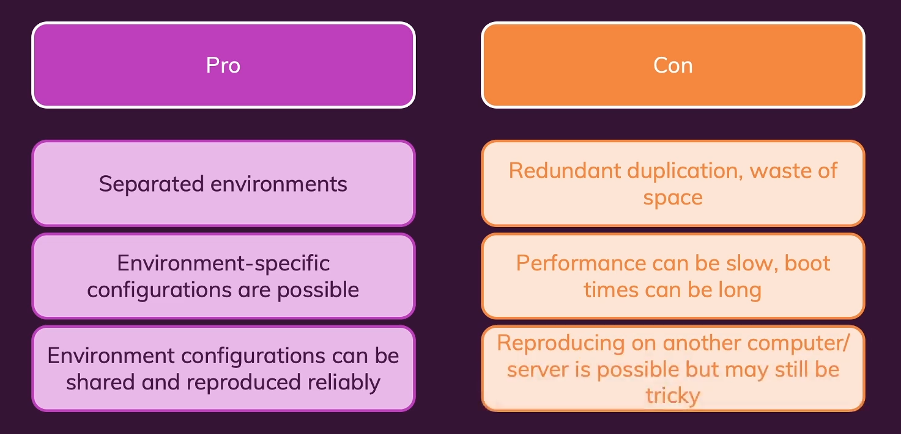

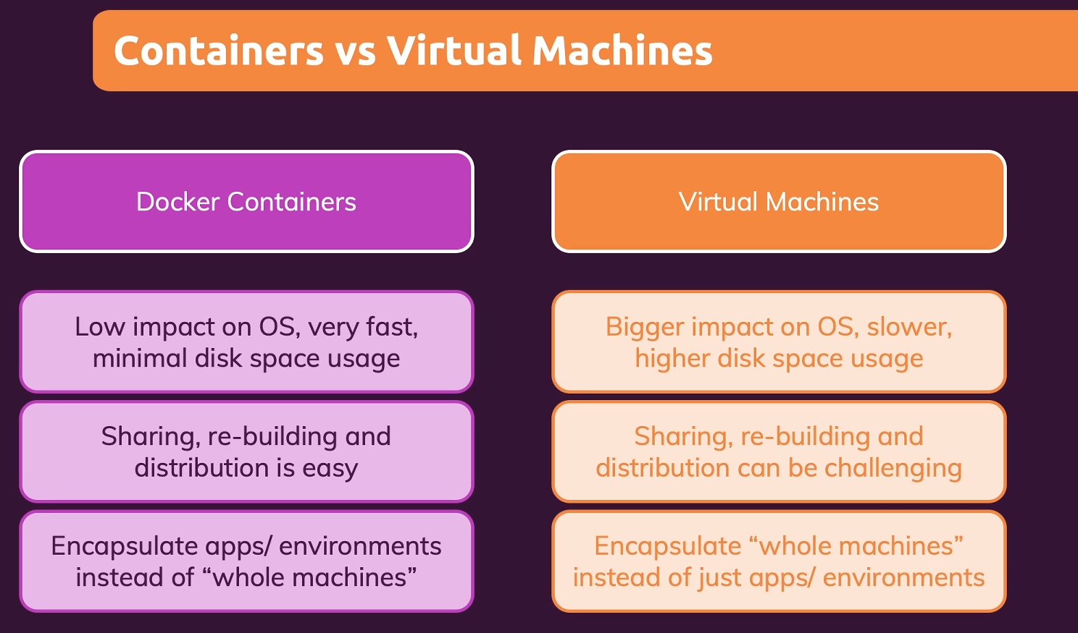

Note: By using the Docker, we can export entire environment into a configuration file and install it on a production environments which are residing at remote.

# Docker Setup

Browse the site [www.docker.com](http://www.docker.com) and navigate to docs under Developers section.

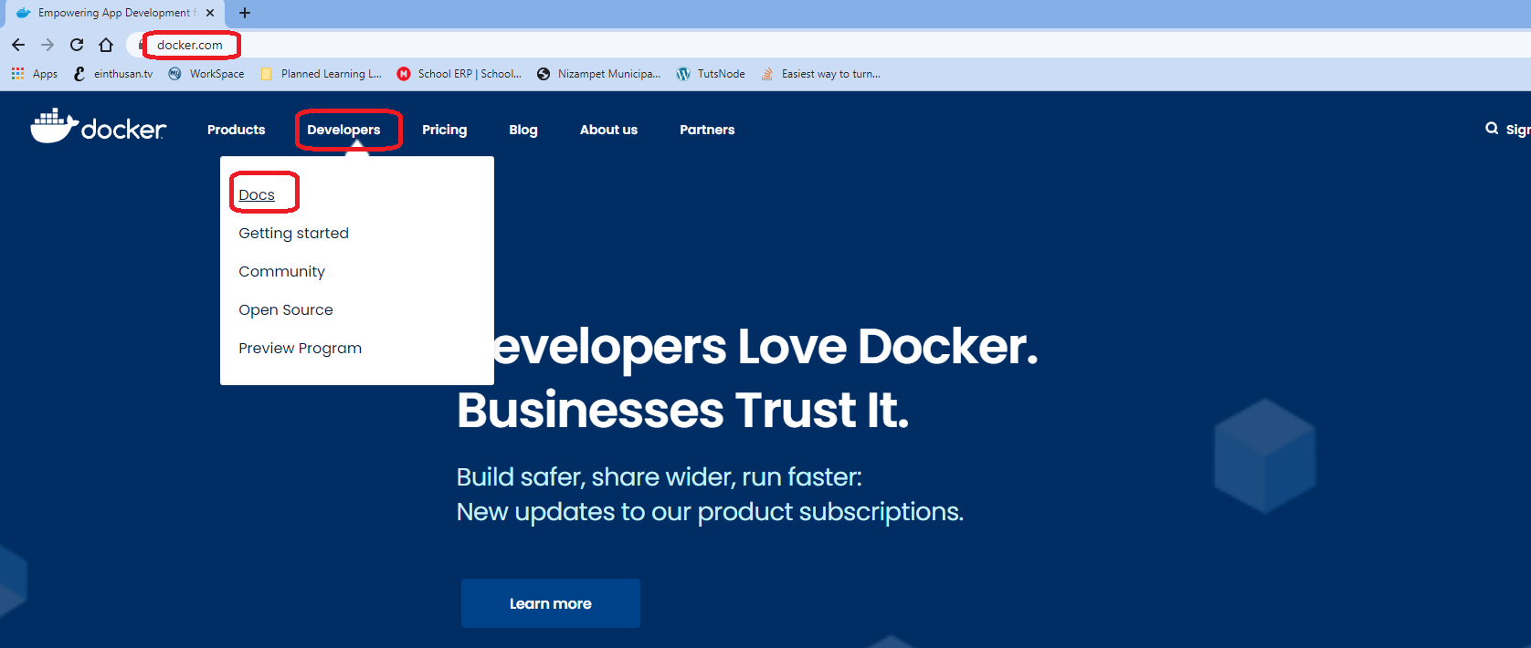

Click on Download and Install and read the documentation for the instructions.

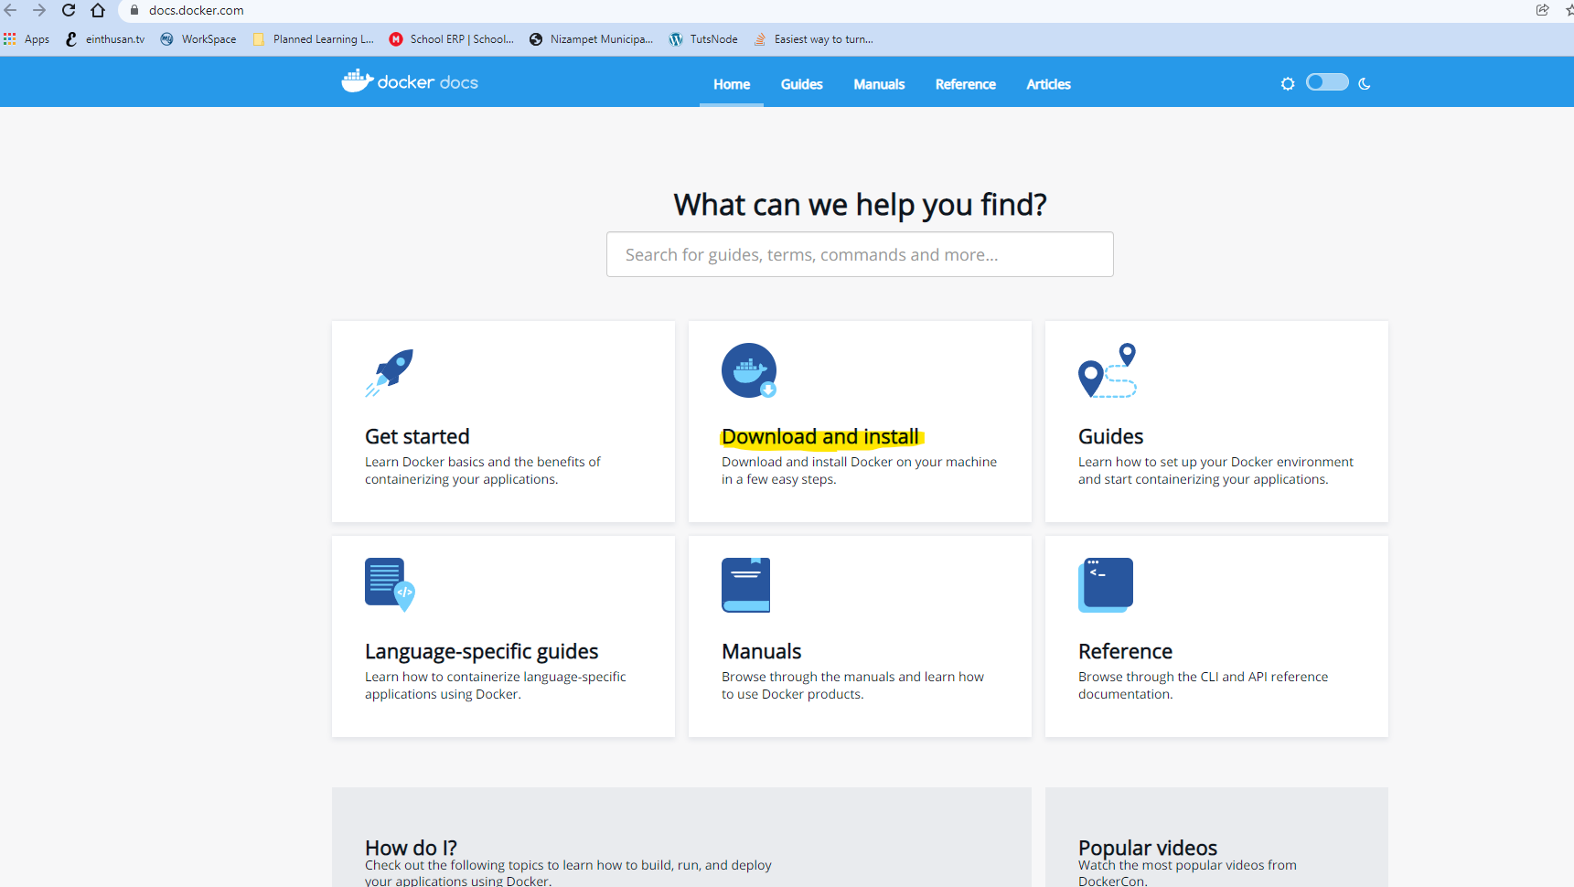

Choose the operating system that you are going to install the docker.

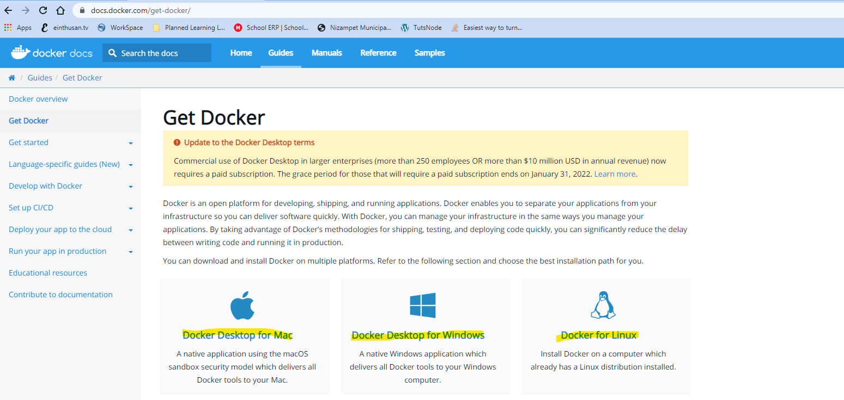

Note: To install docker on Linux platform is completely supportable on any versions without any restrictions because it supports natively. But to install the docker on Windows or MAC there are certain requirements. Please go through the documentation before proceeding.

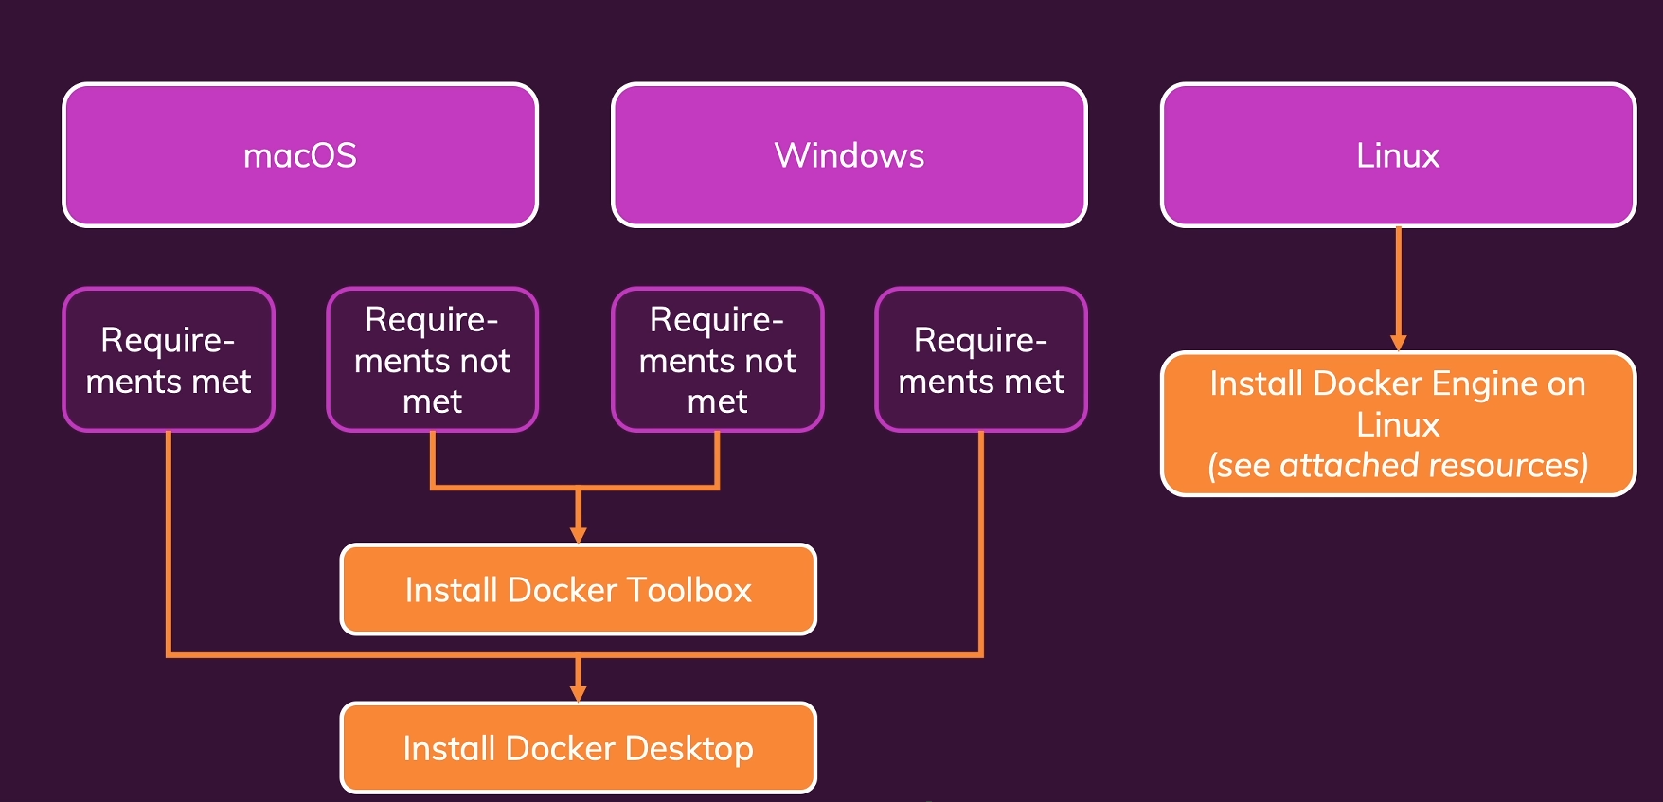

To install the docker on your OS, browse to the page get started and download the respected versions.

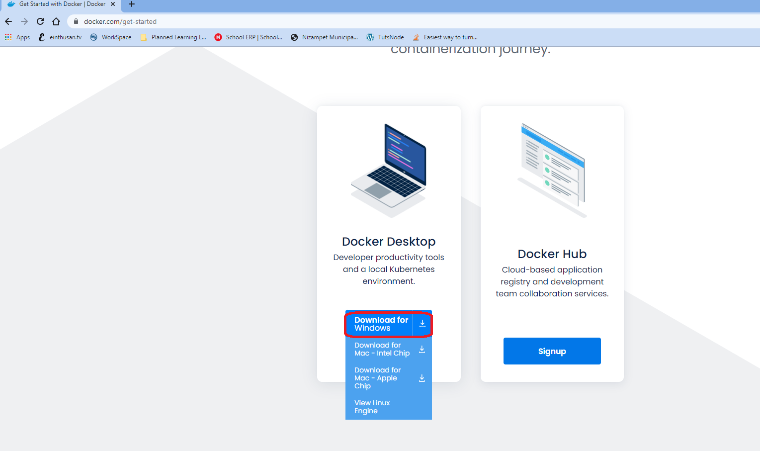

I am downloading docker for windows, below are the minimum requirements to install docker on windows system.

<https://docs.docker.com/desktop/windows/install/>

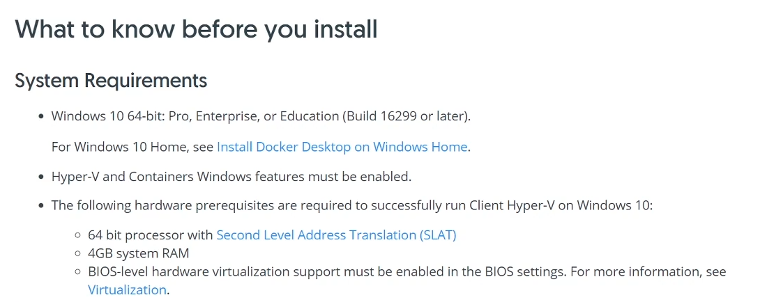

If Hyper-V is not enabled on your system, you can enable those with the below one command.

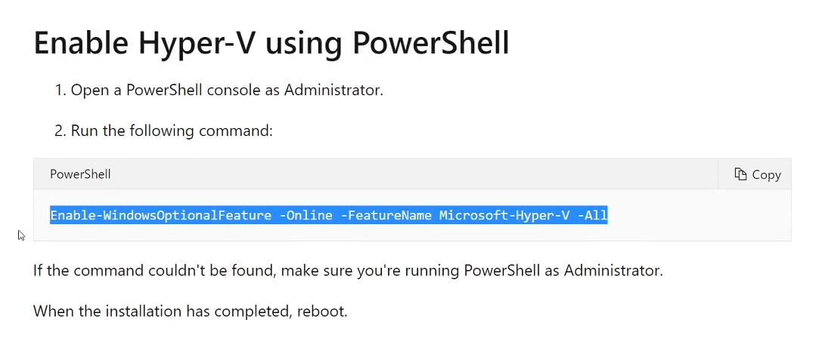

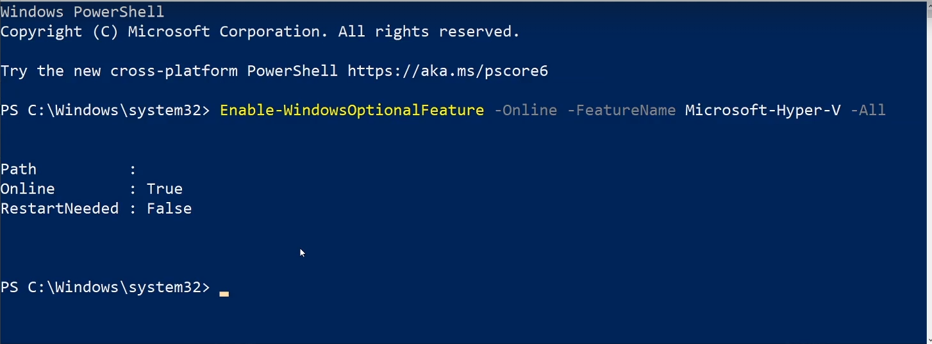

On my system, I had already enabled Hyper-V. So I don’t need to enable it again.

If you are using windows 10 Home, you need to enable Windows Subsystem for Linux (WSL) also.

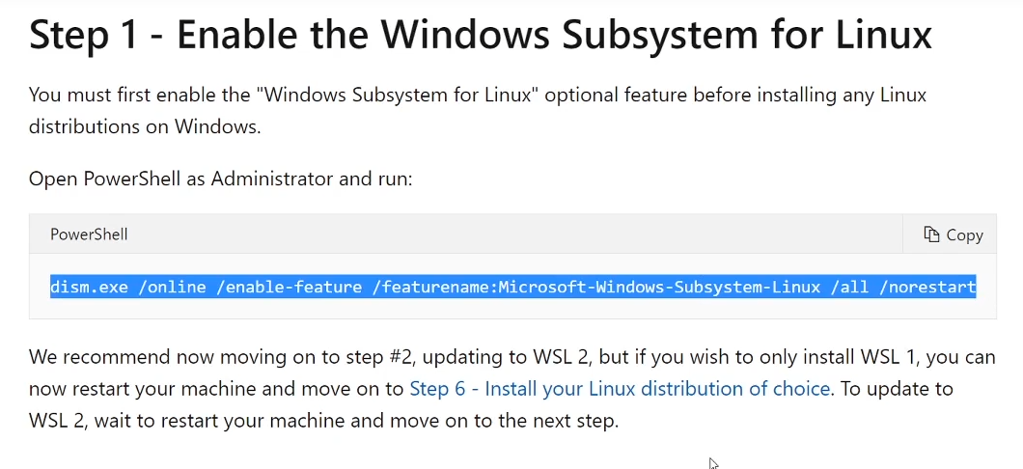

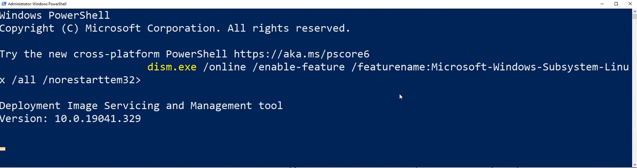

For me I didn’t installed any as I am windows 11 and enabled Hyper-V already. Double click on exe file to proceed with the installation.

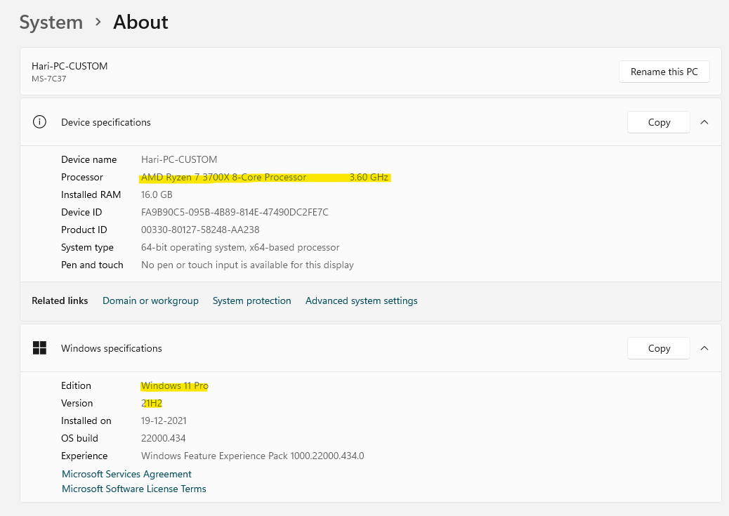

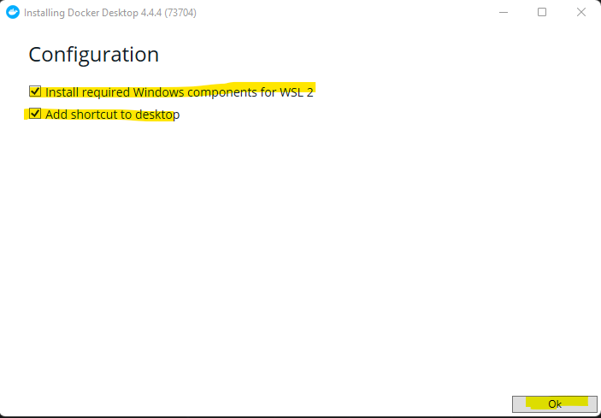

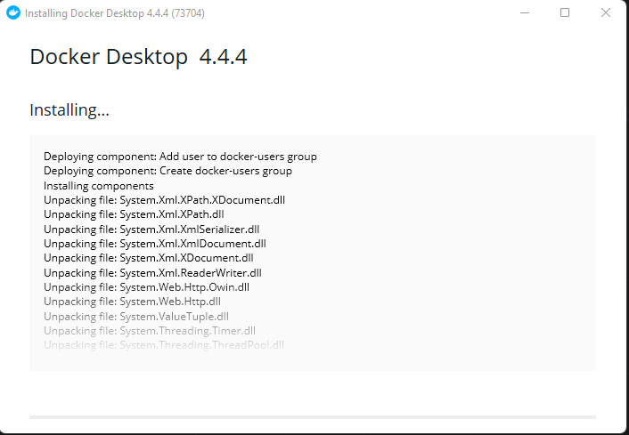

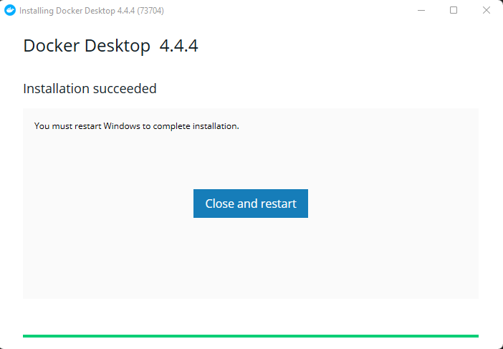

After restart when you start the docker desktop, you will get a message like below which describes to enable the WSL2 on windows.

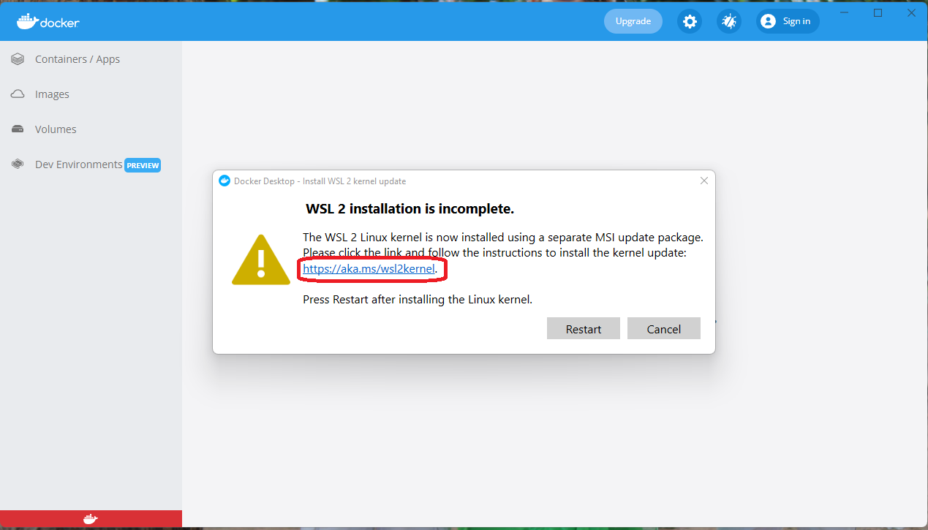

Which opens a separate webpage when you click on the certain link.

<https://docs.microsoft.com/en-us/windows/wsl/install-manual#step-4---download-the-linux-kernel-update-package>

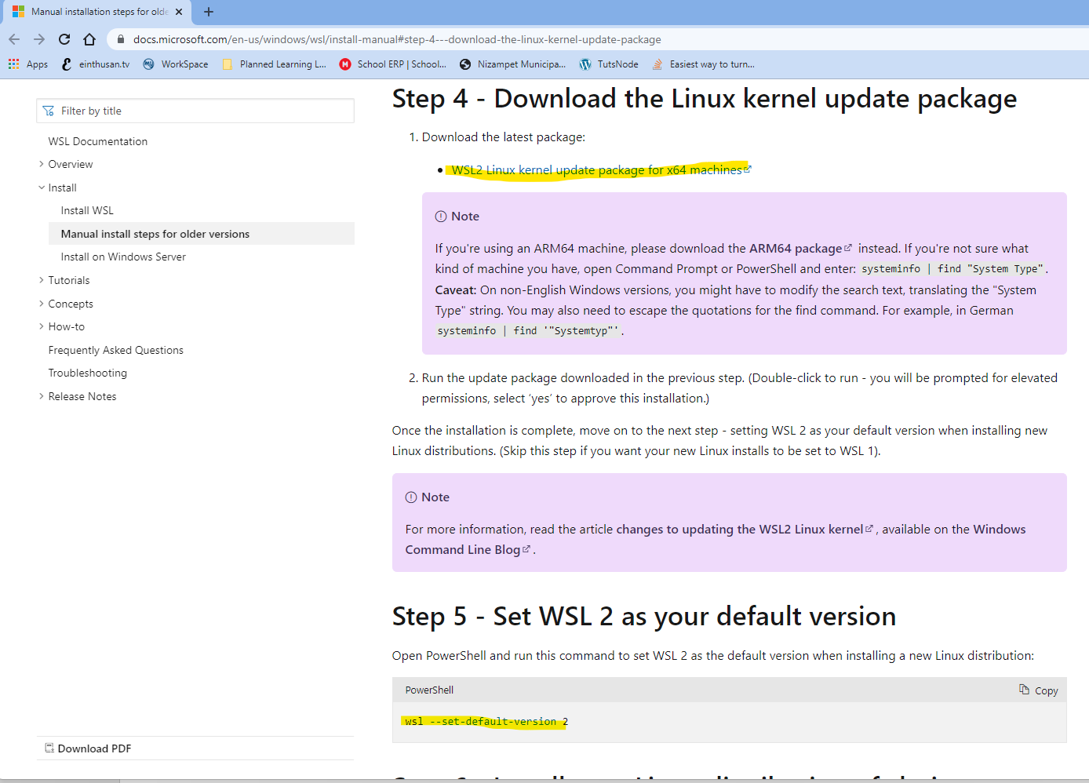

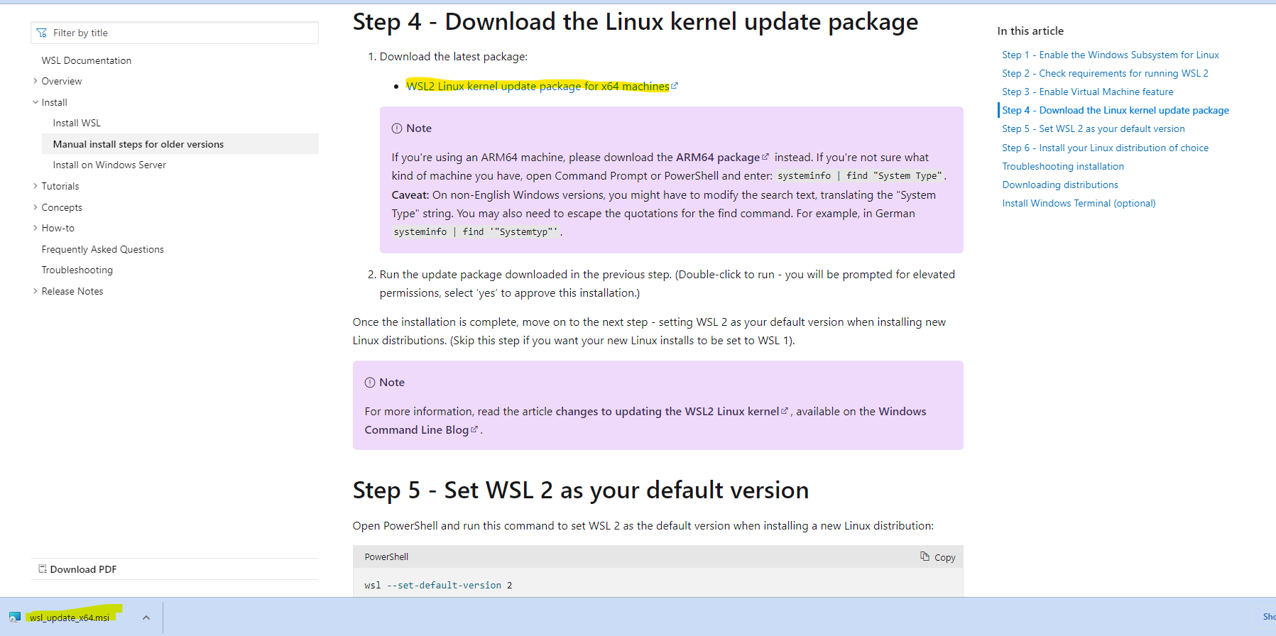

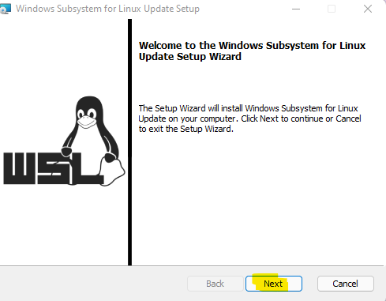

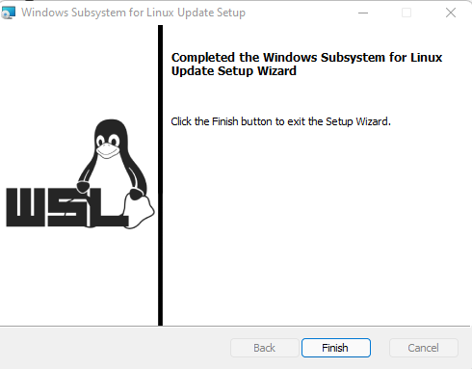

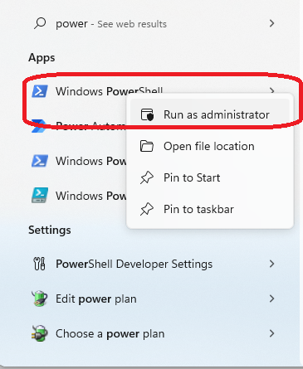

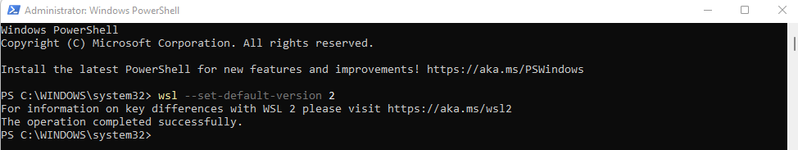

Now open the Microsoft store and search Ubuntu and get that Ubuntu 20.04 LTS.

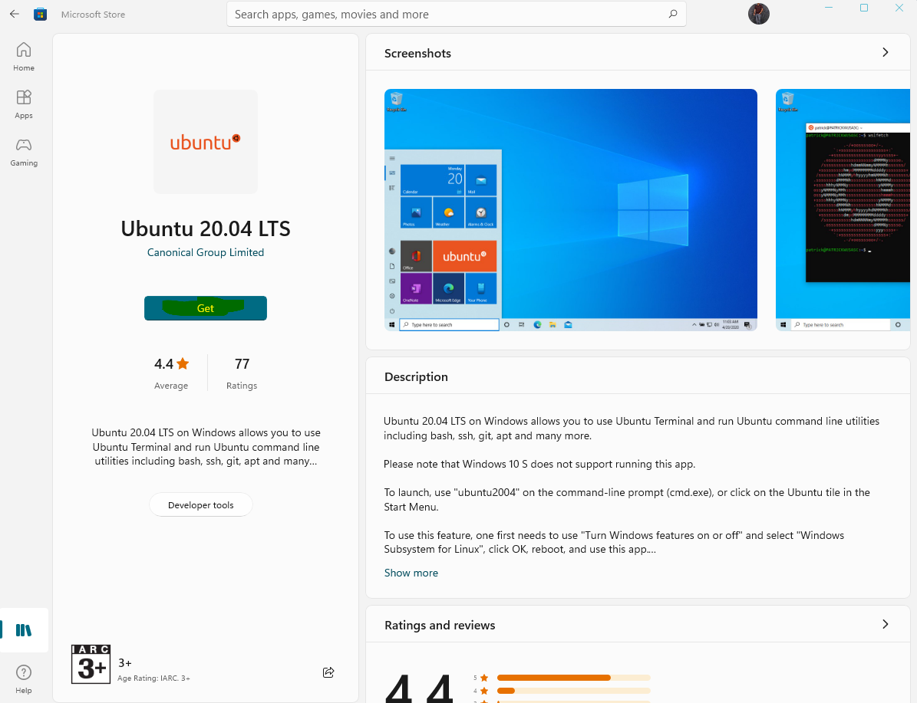

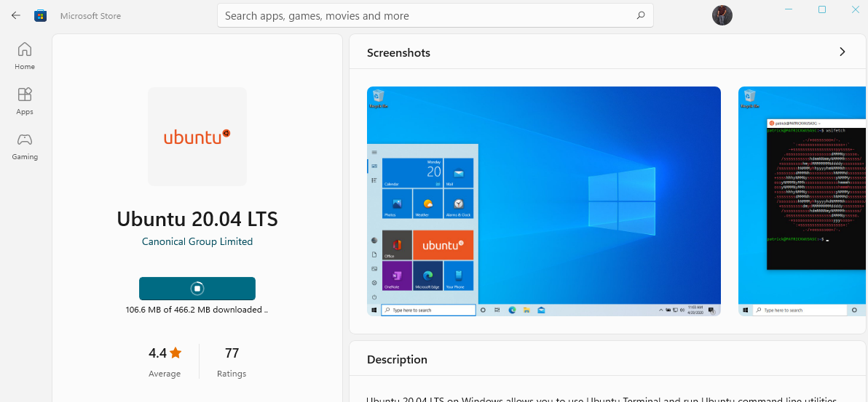

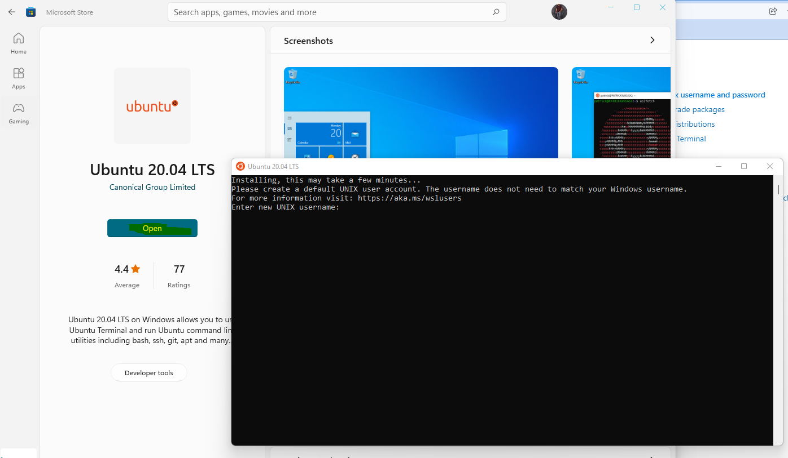

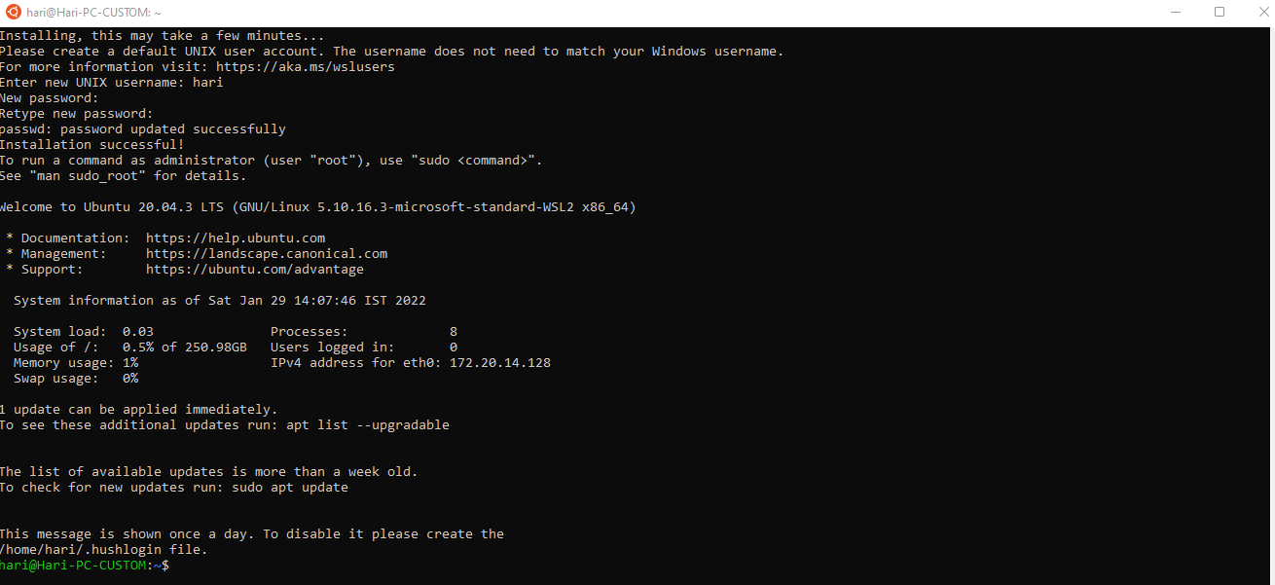

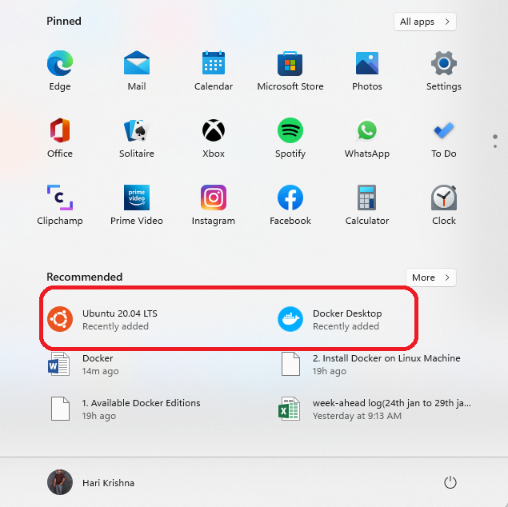

Now restart the machine by clicking on restart as shown below.

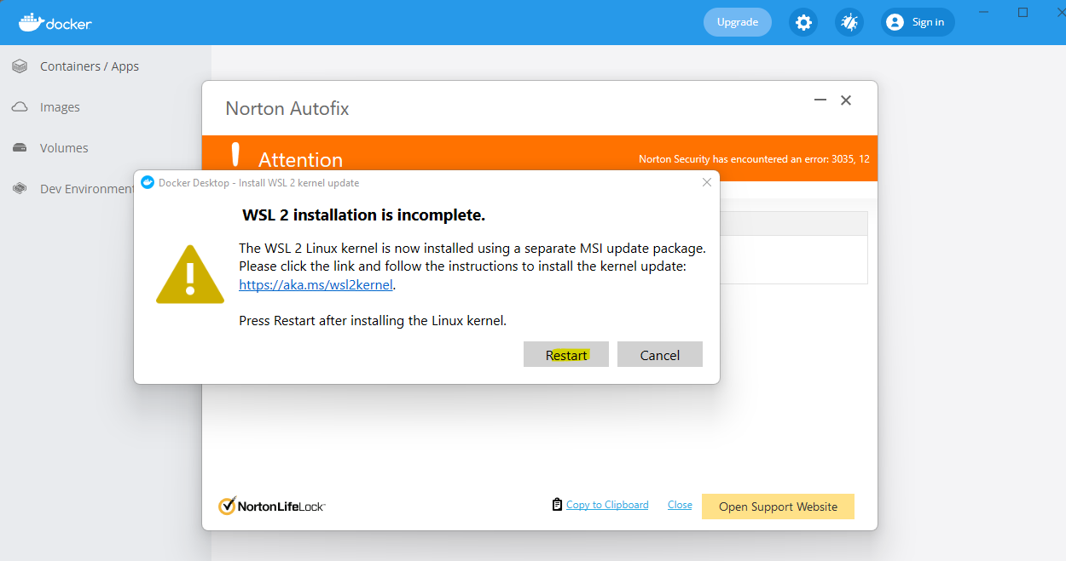

If everything goes well, finally you will be able to see this screen as shown below

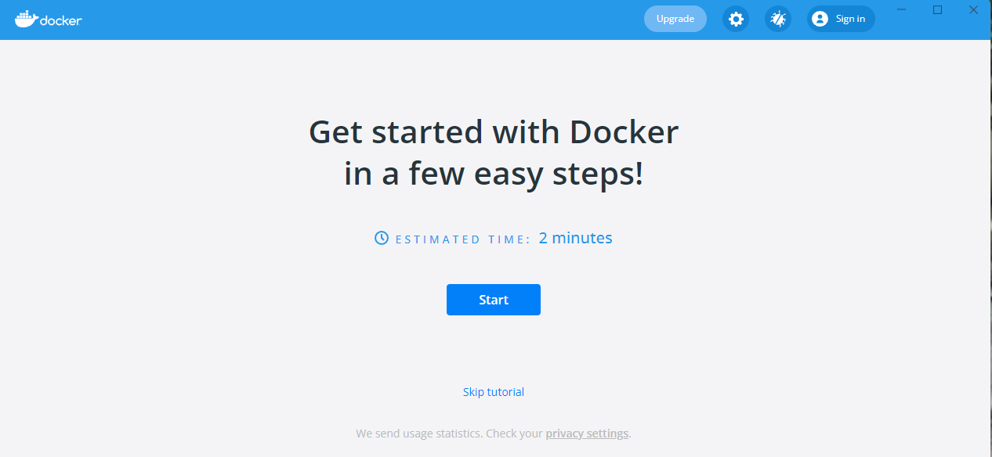

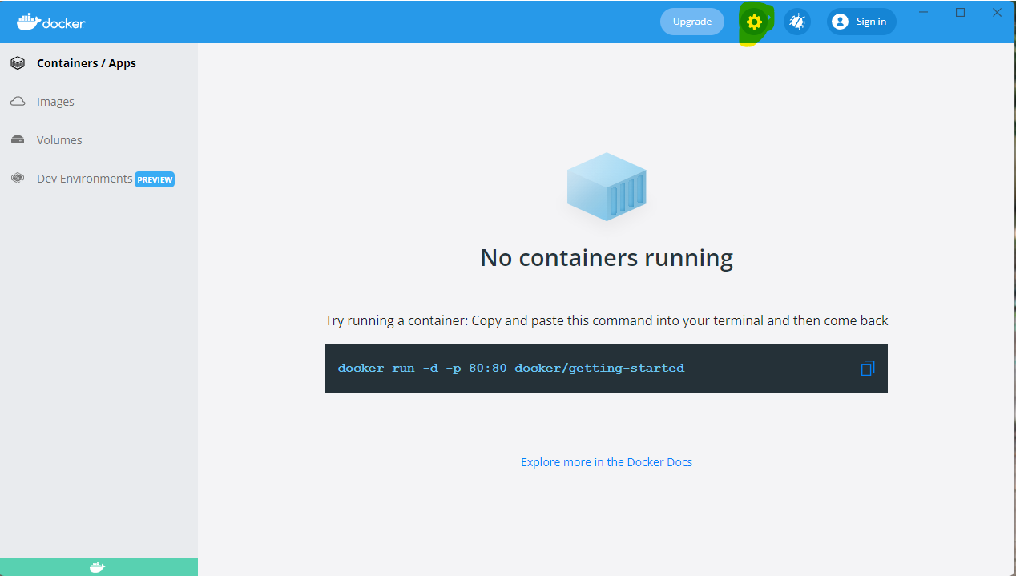

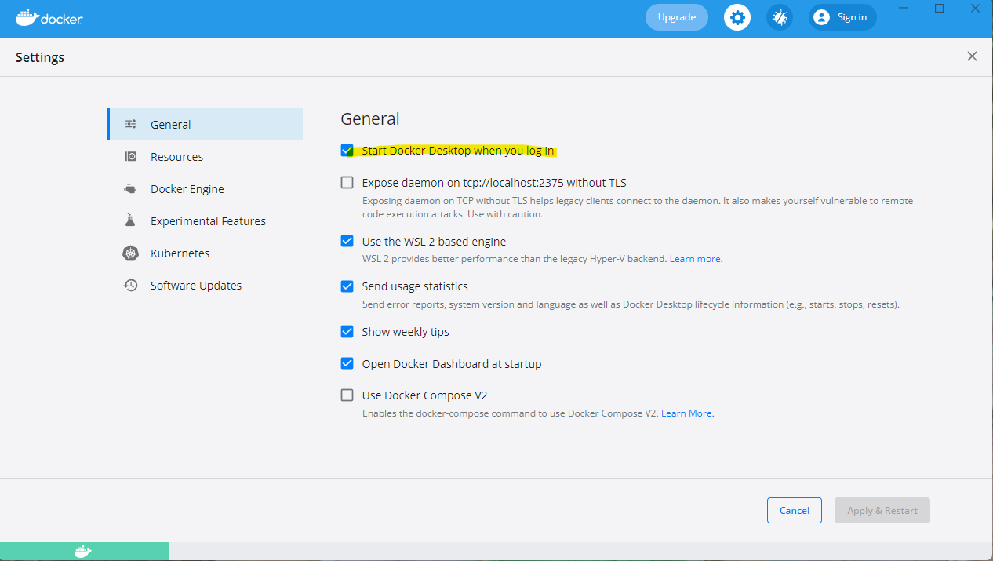

Once you installed docker correctly, issue the following command on command prompt and see the following output.

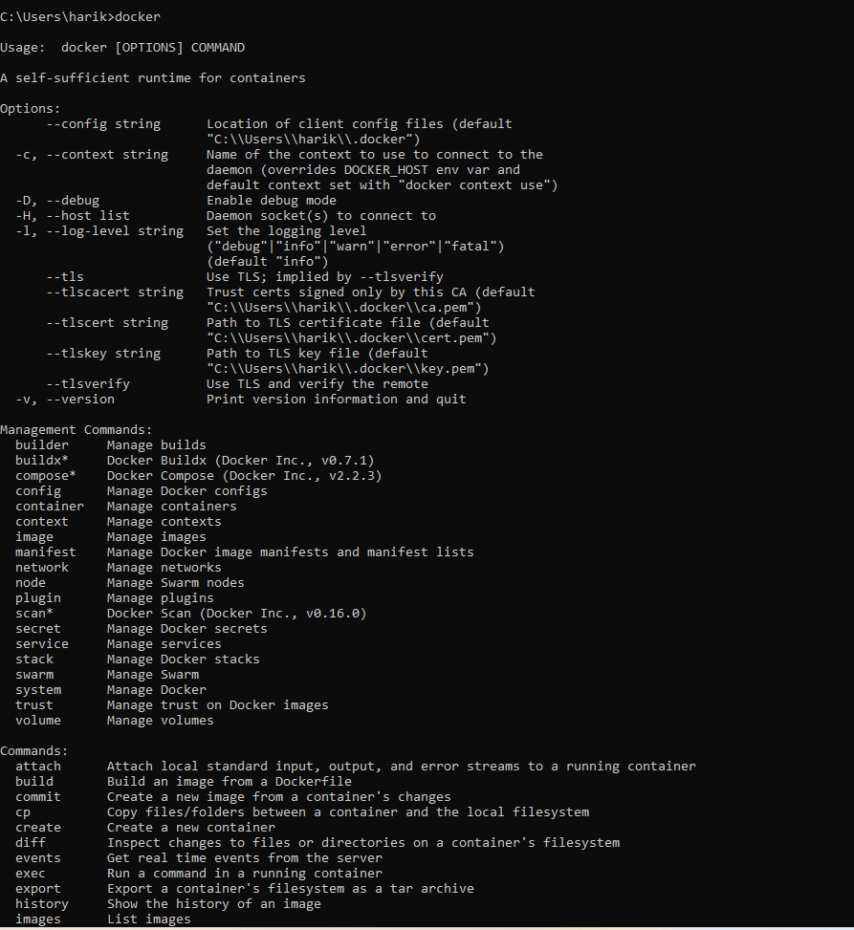

If you don’t have windows 10 and lower than it, then the installation procedure is different you need to install docker tool box.

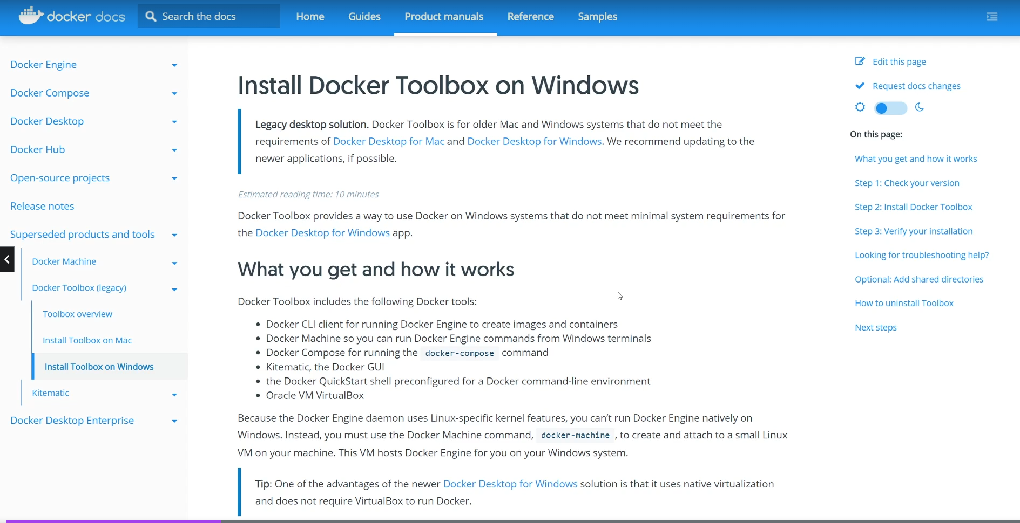

So docker tools can’t directly installed on windows machine, you need to install a virtual machine with Linux operating system and install the tools on top of virtual machine.

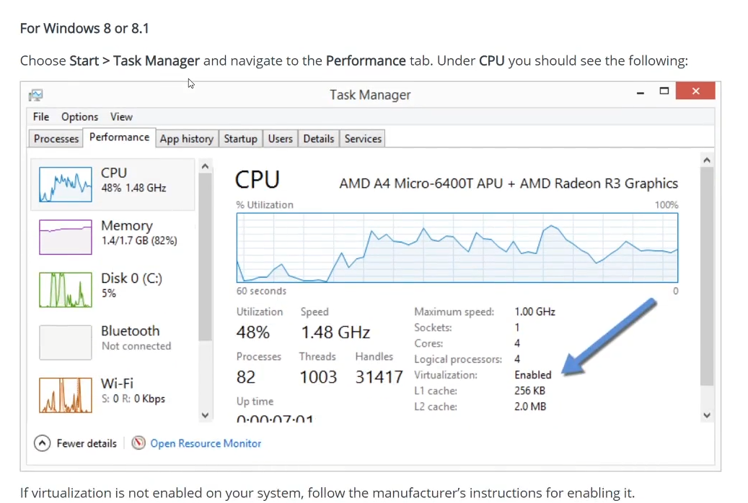

Docker toolbox installation instructions are mentioned here:

<https://github.com/docker-archive/toolbox>

If you can’t able to install docker on your desktop and you don’t have environment, you have online labs at here:

<https://labs.play-with-docker.com/>

Now install visual studio code editor from the website <https://code.visualstudio.com/>

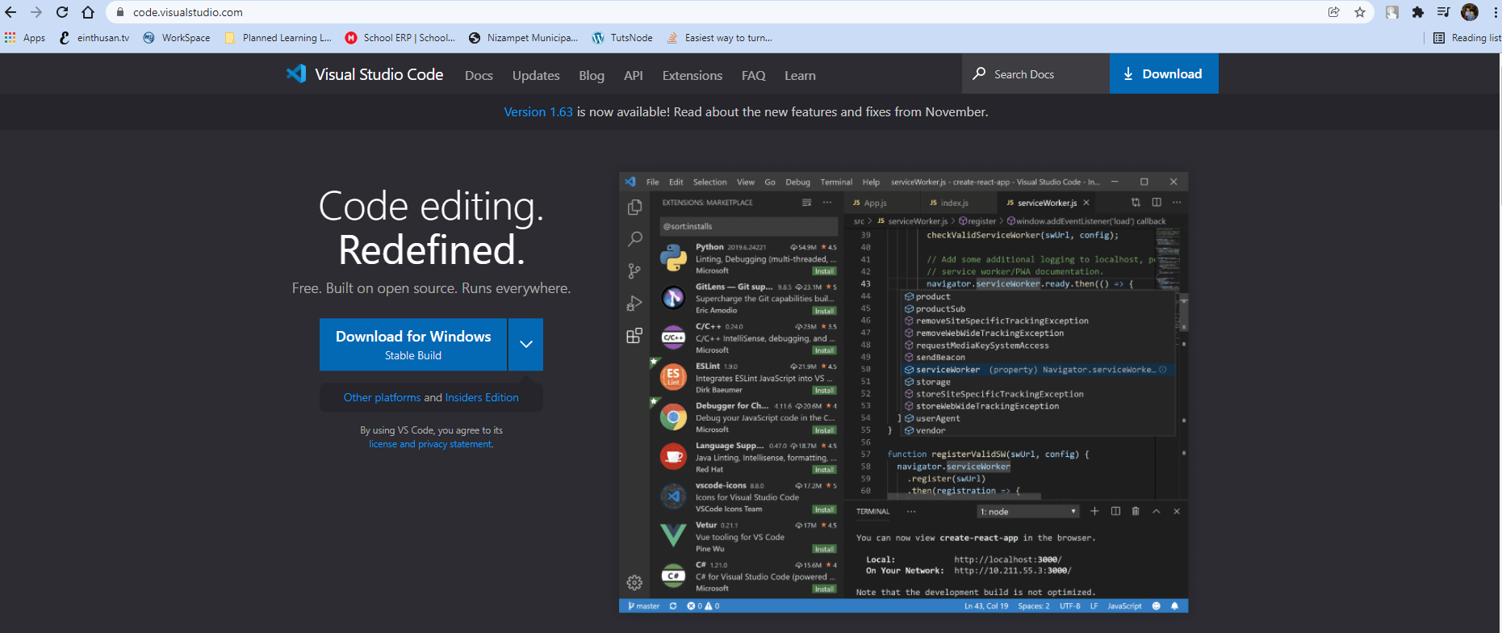

Once install the Visual studio code editor, install plugins like docker & prettier on visual studio code to write some code on editor easily.

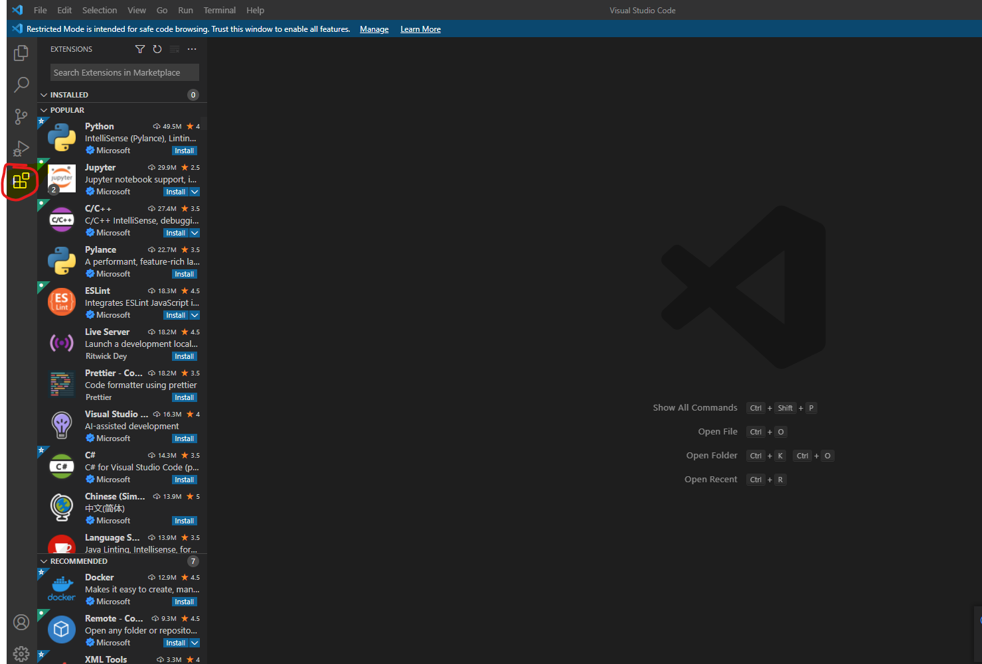

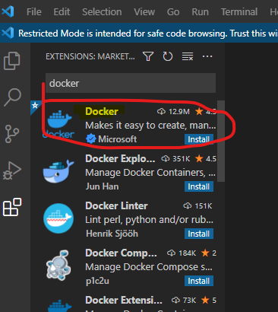

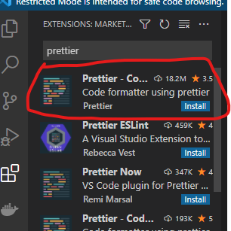

With that let start to get our hands dirty by creating a first container.

I had placed the code at my github repository fetch the code to locally from master branch.

<https://github.com/harikrishna83/Docker-firstdemo-handson/tree/master>

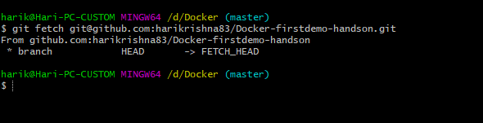

Now open the visual studio code and load this project as shown below.

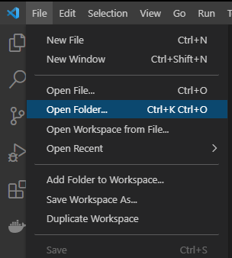

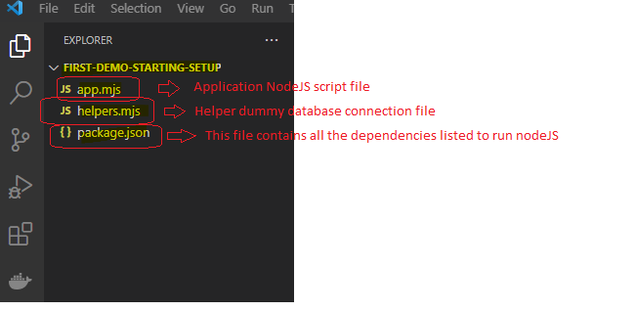

Now create a file with the name Dockerfile in this project with the below content.

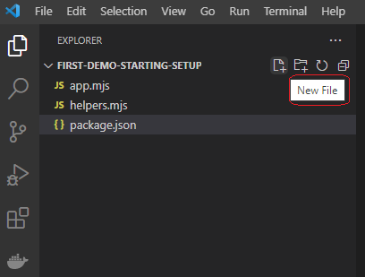

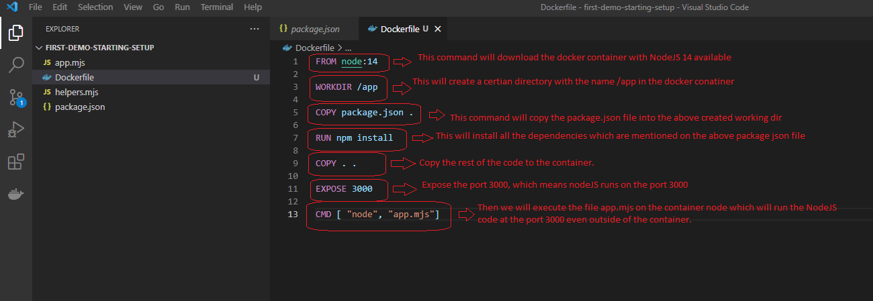

Now with the docker file created, we open a terminal from Visual studio code to execute this code.

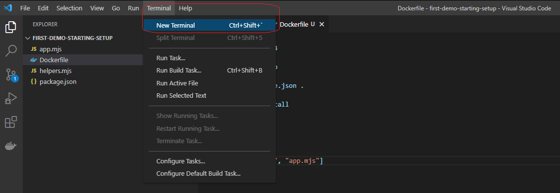

Once you launch the terminal, execute the following command “docker build .”

Note: As you launch the terminal inside the editor it will commands only inside the directory.

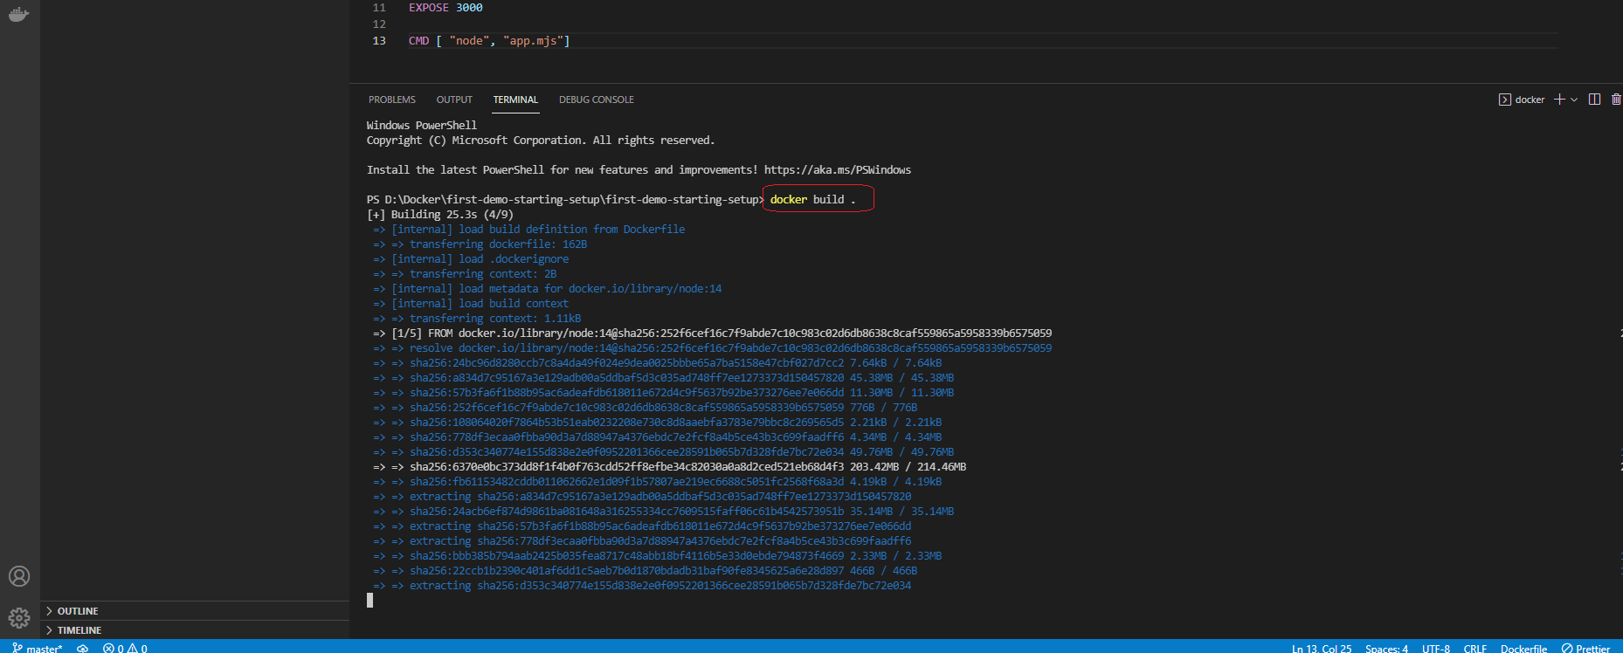

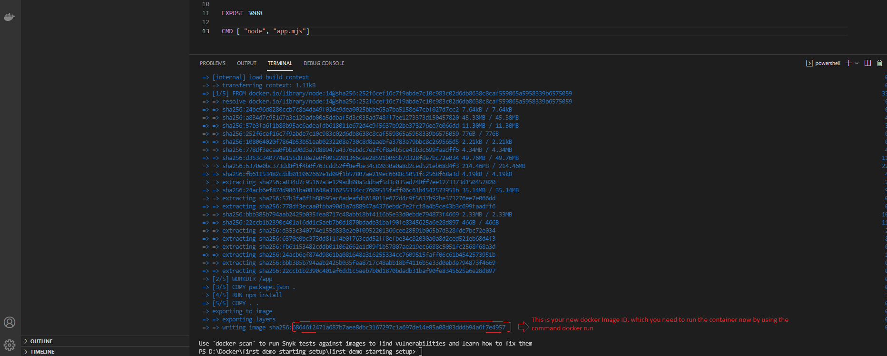

Now you need to run the image that we have built above by using the command “docker run <image ID>”. However we are exposing a port 3000 we need to give an option -p 3000:3000 which means from host 3000 post will be connected to the docker container port 3000.

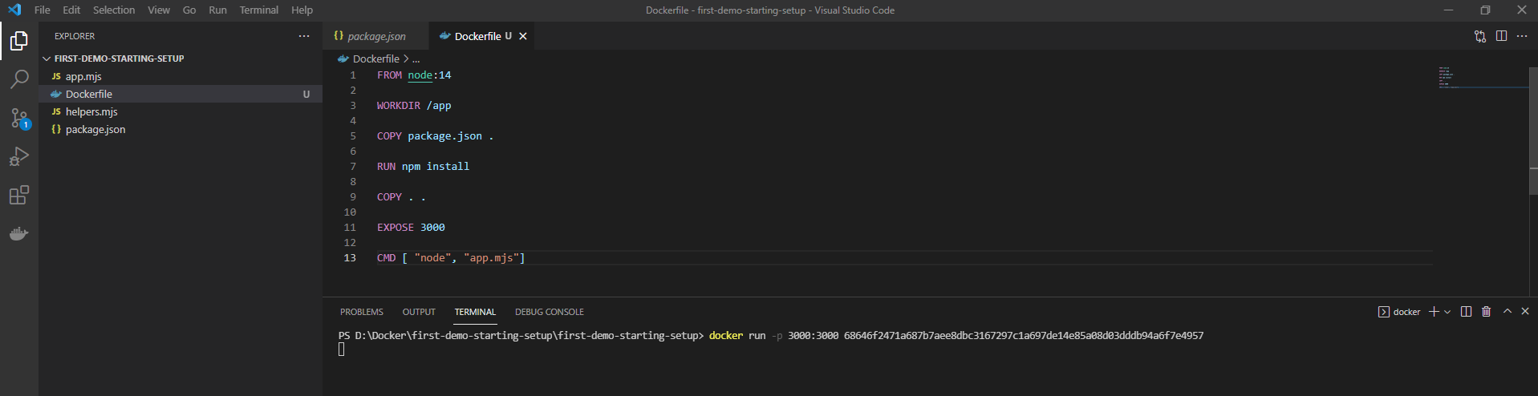

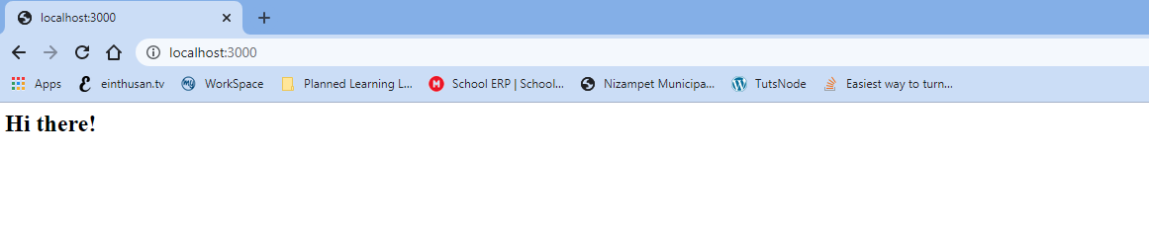

Now as you can see that container is running with the NodeJS application on port 3000 and exposed it to outside also.

In order to shutdown the container, open another terminal by clicking on “+” sysmbol.

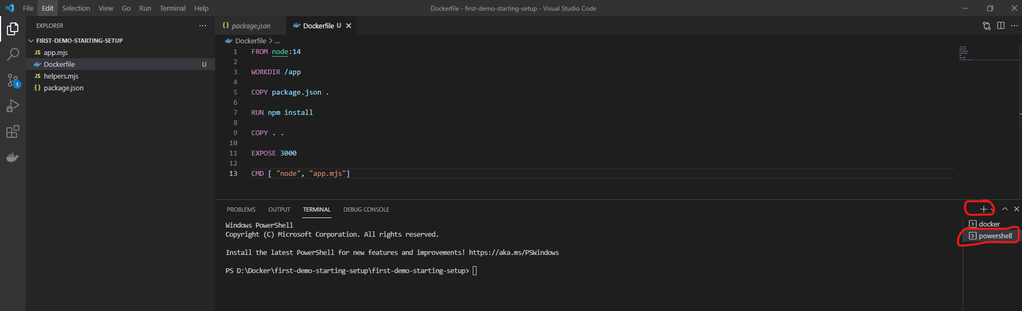

Issue the command “docker ps”, which will list all the running docker containers as of now.

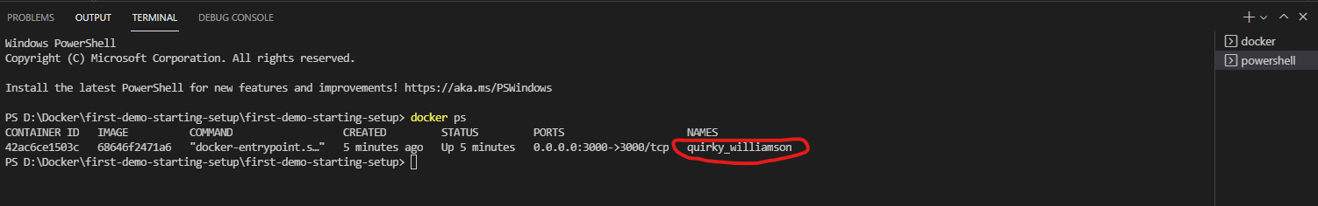

Now copy the name and issue the following command “docker stop <name>”

